**Name : Shahzadi Begum Shaikh Rafique**

**CSharp Assignment 5**

// Q1 Assign5

using System;

using System.Collections;

using System.Collections.Generic;

using System.Linq;

using System.Text;

using System.Threading.Tasks;

namespace Assign5CSharp

{

public class Array

{

static void Main(string[] args)

{

string[] arr_str = new string[8];

ArrayList arr = new ArrayList();

arr.Add("Mumbai");

arr.Add("Pune");

arr.Add("Aurangabad");

arr.Add("Beed");

arr.Add("Nanded");

Console.WriteLine("After Copy: ");

arr.CopyTo(arr_str);

foreach (var elements in arr)

{

Console.WriteLine(elements);

}

Console.WriteLine();

arr.Sort();

Console.WriteLine("Sorted Array List : ");

foreach (string i in arr)

{

Console.WriteLine(i);

}

Console.WriteLine();

Console.WriteLine("Reverse Array List : ");

arr.Reverse();

for (int i = 0; i < arr.Count; i++)

{

Console.WriteLine(arr[i]);

}

Console.WriteLine();

arr.Clear();

Console.WriteLine("After Clearing The Array List " + " Number of Elements Are : " + arr.Count);

Console.WriteLine("Press Enter To Get Out Of Console : ");

Console.ReadKey();

}

}

}

Output

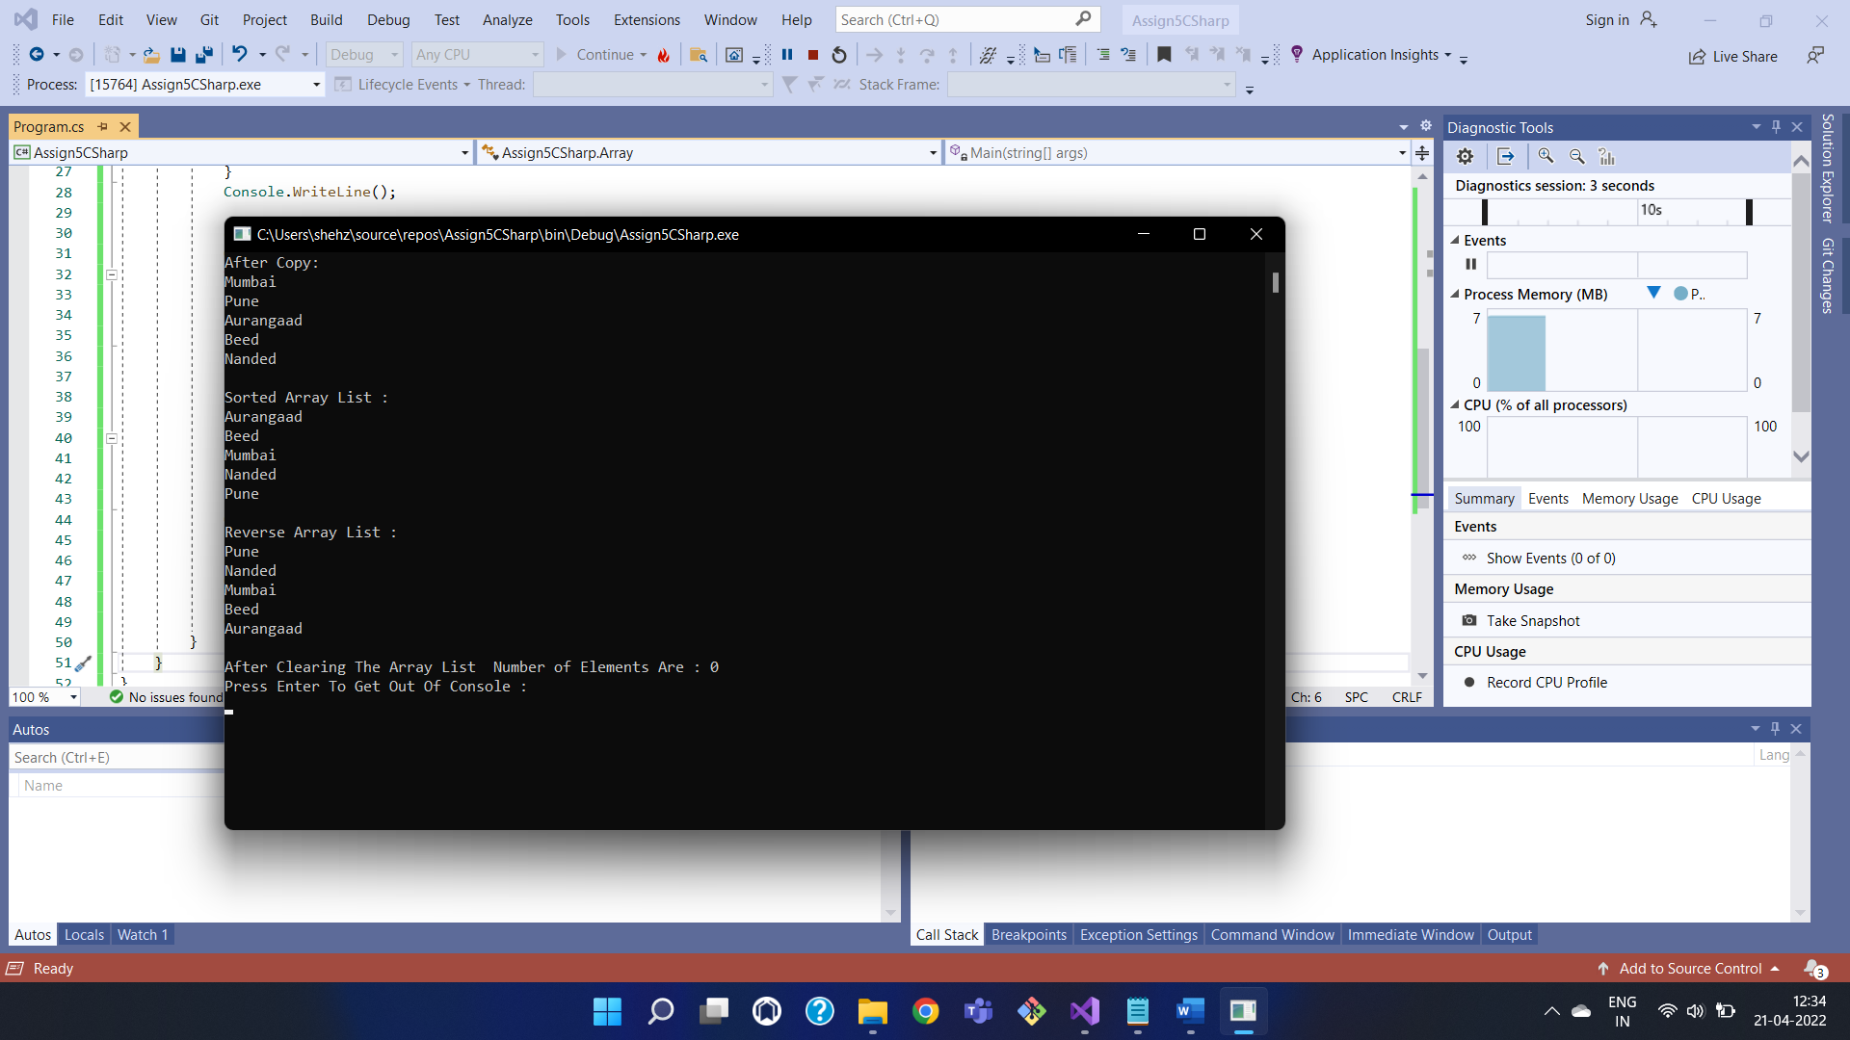

// Q2 Assign 5

using System;

using System.Collections;

using System.Collections.Generic;

using System.Linq;

using System.Text;

using System.Threading.Tasks;

namespace CsharpAssignment_5

{

class EmployeeData

{

public int EmpId { get; set; }

public string EmpName { get; set; }

public int EmpAge { get; set; }

public decimal EmpSalary { get; set; }

public EmployeeData(int empid, string empname, int empage, decimal empsal)

{

EmpId = empid;

EmpName = empname;

EmpAge = empage;

EmpSalary = empsal;

}

}

class Program2

{

public static void Main(string[] args)

{

ArrayList Emp = new ArrayList();

EmployeeData emp1 = new EmployeeData(125, "Shahzadi", 25, 30000);

EmployeeData emp2 = new EmployeeData(356, "Shazli", 24, 25000);

EmployeeData emp3 = new EmployeeData(124, "Safa", 19, 20000);

Emp.Add(emp1);

Emp.Add(emp2);

Emp.Add(emp3);

foreach (EmployeeData i in Emp)

{

Console.WriteLine("Employee Id : " + i.EmpId);

Console.WriteLine("Employee Name : " + i.EmpName);

Console.WriteLine("Employee Age : " + i.EmpAge);

Console.WriteLine("Employee Salary : " + i.EmpSalary);

Console.WriteLine();

}

Console.ReadLine();

Console.ReadKey();

}

}

}

OutPut

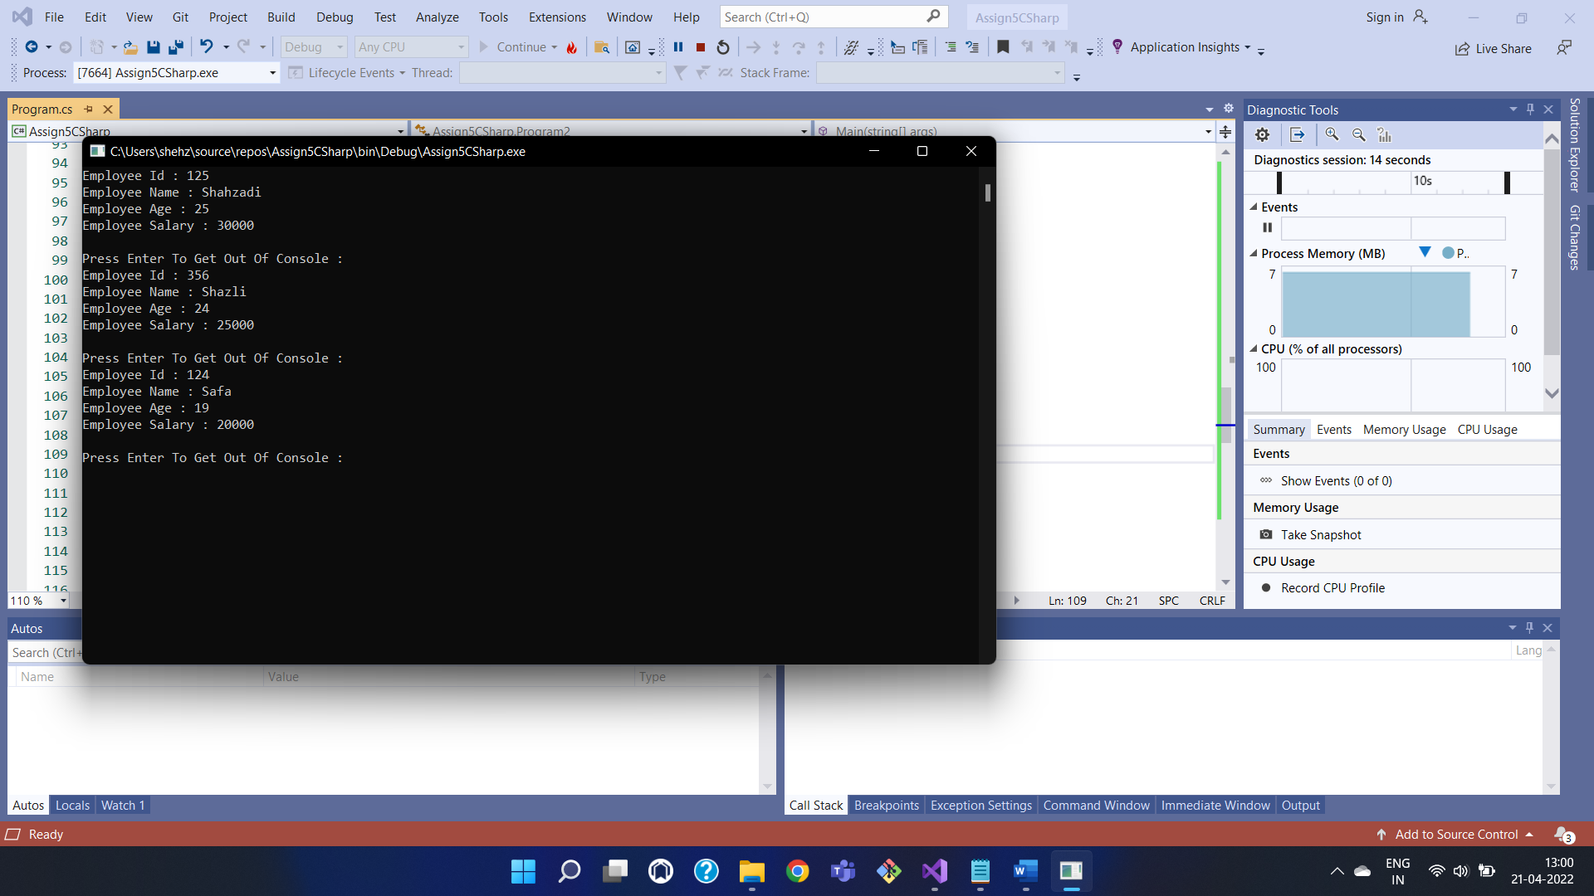

//Q3 Assign 5

using System;

using System.Collections.Generic;

using System.Linq;

using System.Text;

using System.Threading.Tasks;

namespace Assign5CSharp

{

public class EmployeeList<T>

{

private List<T> _List = new List<T>();

public void AddEmployee(T Employee)

{

_List.Add(Employee);

}

public void Show()

{

for (int i = 0; i < _List.Count; i++)

{

Console.WriteLine(_List[i]);

}

Console.WriteLine("Total Number of Employee : " + _List.Count);

}

}

class Program2

{

public static void Main(string[] args)

{

var List = new EmployeeList<string>();

Console.WriteLine("Employee List : ");

List.AddEmployee("Shahzadi");

List.AddEmployee("Shazli");

List.AddEmployee("Safa");

List.Show();

Console.WriteLine("Press Enter To Get Out Of Console : ");

Console.ReadLine();

}

}

}

OutPut

